First Council Facebook Programming October 19-25, 2015
Facebook post content will be determined weekly for upcoming promotions, events, entertainment and holidays. Whenever possible, posts will include a link to corresponding information on the First Council Casino website or other Facebook pages that are linked to First Council. This practice is critical in driving new Facebook fans, providing additional information to the viewer, and increasing awareness of the website.

Supplemental posts featuring new information or time sensitive announcements will be transmitted, as content is made available to MOSAK by designated staff on property. Supplemental posts may include, but are not limited to, winners, photos or video of live entertainment, progressive jackpot updates, weather information, related local news, etc. These proposed posts may shift depending on supplemental content and Fan posts.

DATE |  | POST | URL | IMAGE
Monday  October 19  9:20am | Food Offer  The first five fans to claim this offer will receive 25% off one entrée at FlatWater Bar & Grill. Valid Sunday-Thursday only, excluding alcohol. Cannot be combined with any other offer. Offer is valid October 19-29, 2015. |  |  |  | 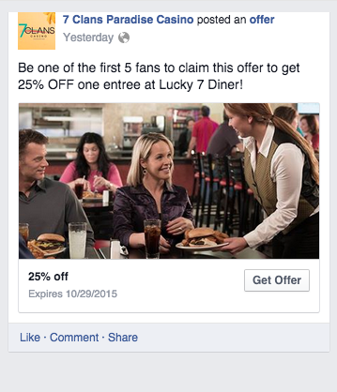
Pm post  11:20am | Thank you for showing your support.  NOW-October 31, redeem 1,000 points or buy this commemorative hat for $25. For every hat sold, we’ll donate $10 to fight breast cancer. |  |  |  | 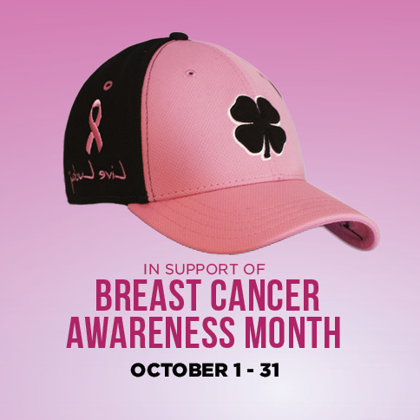
Tuesday  October 20  9:05am | Don’t miss your next chance to rake in CASH!  Every Saturday NOW-November 14: Come WIN your share of over $50,000! Earn entries Saturdays only from 8am-9pm. More details HERE: |  | http://firstcouncilcasinohotel.com/casino/promotions/?utm_source=Web&utm_medium=504x504&utm_campaign=First%20Council%20Promotions |  | 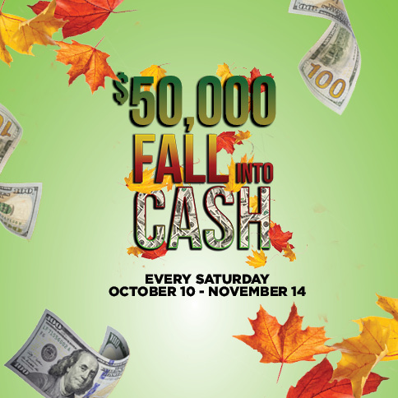
PM Post  3:20pm | Just for fun on a Tuesday…  If your life got “stuck” at one age, what age would you choose and why?
Wednesday  October 21 | Now, this is a day to celebrate! Happy National Pumpkin Cheesecake Day!  What’s your favorite pumpkin treat?  - Cheesecake  - Latte  - Pie  - Other
Pm post | It’s prime time to DINE!  Enjoy a juicy and delicious prime rib for just $13 tomorrow at FlatWater. Plus, we’ve got our $18 snow crab special today! |  | http://firstcouncilcasinohotel.com/dining/ |  | 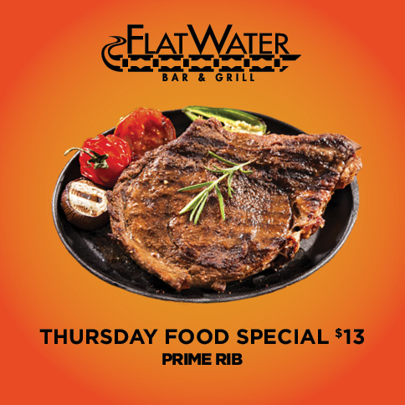
Thursday  October 22  10:20am | We’re just 9 days away from Halloween and our Monster Mash Costume Party!  Dress to impress and you could take home $500 Council Cash! Plus, ALL participants will grab $10 Council Cash. Details HERE: |  | http://firstcouncilcasinohotel.com/casino/promotions/?utm_source=Web&utm_medium=504x504&utm_campaign=First%20Council%20Promotions |  | 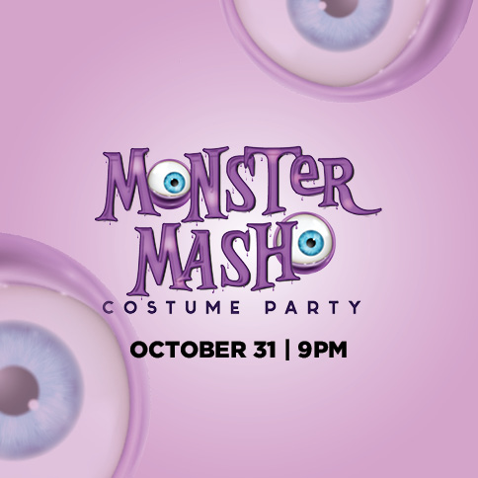
Pm post  3:10pm | Can’t get enough of this one!  Who’s hearing it LIVE with us when REO Speedwagon (TAG) takes the First Council stage on November 6?  Get your tickets NOW: |  | https://youtu.be/rcKFtyy1FPM  http://firstcouncilcasinohotel.com/entertainment/?utm_source=Web&utm_medium=504x504&utm_campaign=First%20Council%20Entertainment
Friday  October 23  10:05am | Get in the GROOVE with KC and the Sunshine Band (TAG)!  Tickets for the November 21 show are still ON SALE: |  | http://firstcouncilcasinohotel.com/entertainment/?utm_source=Web&utm_medium=504x504&utm_campaign=First%20Council%20Entertainment |  | 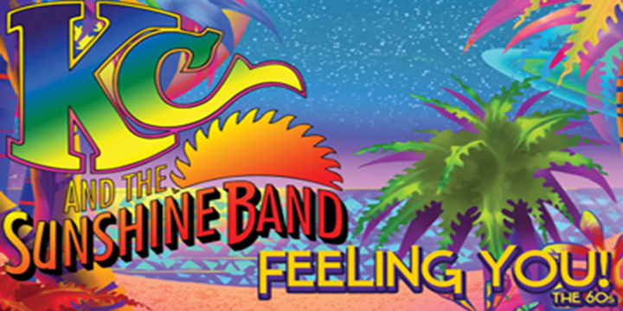
Pm post  2:45pm | Cheers to the weekend!  Any fun plans? SHARE them with us!  Don’t forget about out next round of Fall into Cash drawings TOMORROW.
Saturday  October 24  8am | Earn entries NOW for your chance to rake in fall CASH!  Our first $500 random reward drawing is at 5pm. Be sure to stick around for our $1,000 & $5,000 CASH drawings! Get details on drawing times here: |  | http://firstcouncilcasinohotel.com/casino/promotions/?utm_source=Web&utm_medium=504x504&utm_campaign=First%20Council%20Promotions
Pm post | Halloween is one week from today! Still looking for the perfect costume? Well, if you’re a TV fan, you just mind find one here… |  | http://www.buzzfeed.com/brettvergara/ridiculously-clever-halloween-costumes-every-tv-lover-wil?bffbmain&utm_term=.lfQbYGBKw#.wi1D0Q7gY
Sunday  October 25  9:15am | Hit the tables EVERY Sunday-Thursday for your shot at a share of $1,000 each week!  Hit a suited blackjack or a straight on Ultimate Texas Hold ‘em using both hole cards to qualify. See Table Games for details: |  | http://firstcouncilcasinohotel.com/casino/table-games/?utm_source=Web&utm_medium=504x504&utm_campaign=First%20Council%20Table%20Games%20Promotions |  | 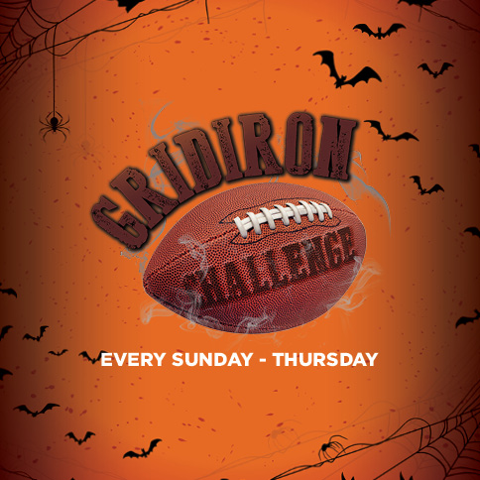
Pm post  4:20pm | Take the stage for a SCARY good time!  Head to Chilocco Halloween night from 8pm-midnight for Scary-oke Halloween! All participants get $5 Council Cash AND 1st place will get $500 Council Cash! |  | http://firstcouncilcasinohotel.com/casino/promotions/?utm_source=Web&utm_medium=504x504&utm_campaign=First%20Council%20Promotions |  | 