Serasana Competitive Analysis

West Holistic Medicine

http://www.westholisticmedicine.com/

About: Group of practitioners (physicians, nutritionists, acupuncturists, massage therapists, etc.) who are passionate about promoting health and wellness

Social Media Presence: Facebook only

Facebook:

https://www.facebook.com/WestHolisticMedicine?fref=ts

Fans: 198

What they do right:

- Focus on educating fans on what they offer – Integrative medicine

What they do wrong:

- No consistent posting – Just 5 in November and 1 in December
- Not much original content
- Few photos
- No tabs

Holistic Healing Center & Yoga

http://www.holistichealingandyoga.com/

About: Offer yoga, meditation and brain education programs

Social Media Presence: Facebook, Twitter & LinkedIn

Facebook:

https://www.facebook.com/Holistichealingandyoga

Fans: 134

What they do right:

- Share some special offers from LinkedIn (although odd that these offers are posted on LinkedIn in the first place)

What they do wrong:

- Inconsistent postings – Post every few days
- Only one original video posted
- Few photos
- Posts are too long and wordy – No one is going to read all of it
- Page is boring – no engagement

Twitter:

https://twitter.com/HHY

Followers: 8
Following: 49

What they do right:

- Nothing

What they do wrong:

- Have not tweeted
- No profile or header images
- Should not have a Twitter especially since there’s an icon on the website to direct people to a completely inactive page

Yoga Yoga

http://www.yogayoga.com/

About: Focus on various types of yoga; have four locations including a healing spa in Westlake

Social Media Presence: Facebook and Twitter

Facebook: Shared for all locations; focused on West Anderson Lane location

https://www.facebook.com/YogaYogaAustin

Fans: 20,766

What they do right:

- Some original content – Blog posts, videos
- Focus on educating audience about yoga practices
- Their events tab is updated
- Post specials
- Post regularly – 1-2 per day
- Class Schedule Tab – All locations
- Teacher Training Tabs – Contact form for the different types of yoga
- Video tab – Many original videos



What they do wrong:

- While they have a large following, engagement is inconsistent
- Not enough photos
- Not engaging audience more with questions, inspirational quotes, memes, etc.
- Not running post engagement ads
- Cover photo isn’t visually appealing and is partially covered up by profile pic



Twitter:

https://twitter.com/YogaYogaAustin

Followers: 3,158

Following: 1,044

What they do right:

- Tweet regularly
- Tweet links to original content – blogs
- Twitter relevant articles

What they do wrong:

- Too similar to Facebook
- Very few photos
- Don’t engage with followers – Retweet, reply, etc.

Yoga Vida

http://yogavidaaustin.com/
About: Heated power vinyasa flow yoga seven days a week

Social Media Presence: Facebook

https://www.facebook.com/YogaVida

Fans: 1,871

What they do right:

- Post updates on classes

What they do wrong:

- Cover photo isn’t visually appealing or properly sized
- Profile pic isn’t visually appealing
- Don’t post many photos and the ones that they do post aren’t appealing
- No engaging content – tips, questions, informational articles, inspirational quotes, etc.
- Inconsistent posting
- No engagement
- Poor content and no engagement = A bad business page
- Event tab isn’t updated
- Two videos posted are of poor quality
- No additional tabs – Class schedule, Contact Us, etc.

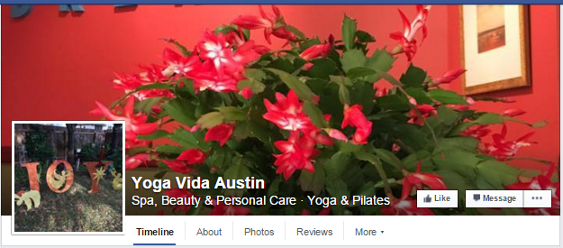

Austin Natural Healing Center

http://m.mainstreethub.com/zacutherapy

About: Pain management center – acupuncture, acupressure, Chinese medicine

Social Presence: Facebook and Twitter

Facebook:

https://www.facebook.com/austinnaturalhealingcenter/timeline

Fans: 37

What they do right:

- Have a tab to join their email list
- Post health tips with engaging images
- Post some inspirational quotes
- Try to be engage – True or False



What they do wrong:

- The About is incomplete
- Lack of photos and videos of their center
- They don’t educate fans on what they do
- Don’t post consistently
- No additional tabs

Twitter:

https://twitter.com/zacutherapytx

Followers: 5
Following: 3

What they do right:

- Tweet regularly
- Header image and profile pic is decent

What they do wrong:

- Not following enough accounts
- Same content as Facebook
- No retweeting, sharing additional content
- Lack of photos

Black Swan Yoga Westgate

https://blackswanyoga.com/

About: Community-driven yoga destination; many locations but we’ll focus on the Westgate location

Social Media Presence: Facebook and Instagram

Facebook: They have a main page as well as pages for different locations including their South Austin location (Westgate) – Will focus on Westgate location

https://www.facebook.com/bsywestgate

Westgate Fans: 2,849

What they do right:

- Posts regularly
- Share fan content – photos of yoga poses
- Post fun photos featuring instructors and clients
- Inspirational quotes
- #PoseoftheWeek feature
- Post class schedule

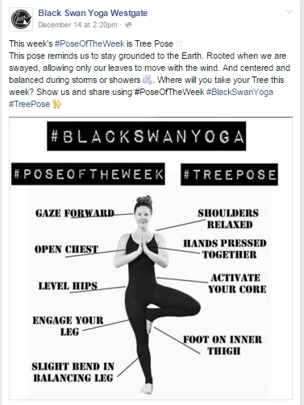

What they do wrong:

- Post class schedule each day but this would be better on a tab – People could plan ahead
- No tabs – Contact us, Join our email club, class schedule, etc.
- Lack of educational or useful posts
- Not a lot of engagement

Instagram:

https://www.instagram.com/bsywestgate/

Followers: 1,514
Following: 1,044

What they do right:

- Showcase interesting poses
- Showcase their studio and people practicing
- Inspirational quotes
- Fun memes



What they do wrong:

- Showcases the fun aspect of performing at Black Swan Yoga, but no focus on health benefits
- Could be a better mixture of fun and educational content
- Some posts have too many hashtags

*Overall, their Instagram is visually compelling and engaging

Wanderlust Yoga

http://austin.wanderlustyoga.com/

About: One-of-a-kind yoga experience that builds strength, flexibility, openness, mindfulness, and vitality

Social Media Presence: Facebook and Twitter

Facebook:

https://www.facebook.com/wanderlustyogaaustin

Fans: 11,920

What they do right:

- Post regularly
- Share articles, photos from studio, #poseoftheweek
- Have a class schedule tab
- Events tab is updated

What they do wrong:

- They have a lot of fans but not much engagement
- They don’t provide valuable information about what they offer
- Don’t educate fans on the practice of yoga
- Services tab is broken
- No additional tabs besides the class schedule tab
- Should be sourcing their fans for more information – ask questions, conduct polls, etc.
- No Facebook giveaways or exclusive specials
- Don’t explain how to do the #poseoftheweek – lack of educating fans

Twitter:

https://twitter.com/wanderlustyoga

Followers: 2,776
Following: 2,850

What they do right:

- Tweet regularly
- Engage – Retweet mentions
- Utilize hashtags
- Updates on future events
- Showcase their New Year’s Eve party sponsors
- Following same amount that is following them

What they do wrong:

- Lack of information about what they provide
- Lack of useful articles, tips, etc.
- Don’t tweet many photos

*Overall, their Twitter is more useful and compelling than their Facebook

Serasana

Social Media Presence: Facebook, Twitter, Pinterest, Instagram

Facebook:
Fans: 434

What you do right:

- Posts that showcase your various teas
- Inspirational memes and quotes
- Interesting facts about yoga, tea, etc.
- Share relevant articles
- Educate about what you offer
- Unique tabs – Own a Serasana and Stay in the Loop

What you could do better:

- Link posts to your website for more information
- Some posts are too lengthy – Shorten posts and link to website instead
- Need more engaging photos and videos
- Twitter tab is broken
- As your page grows, post more regularly
- Size images – preferably 504x504
- Suggest creating a blog on your website – educate your audience and increase web traffic

Twitter:

Followers: 259
Following: 952

What you do right:

- Retweet relevant information
- Tweet links to relevant articles
- Cross-promote with Instagram
- Inspirational quotes/sayings

What you could improve on:

- Tweet more regularly
- Utilize common and custom hashtags
- Engage your target audience with more helpful information about what you provide
- Drive traffic to your website with links
- Tweet more photos

Instagram:

Followers: 270
Following: 678

What you do well:

- Engaging images
- Good mixture of fun and promotional
- Good use of hashtags

What you could improve on:

- Post more regularly
- Post some videos
- Large focus on tea and yoga – would post photos of other wellness services
- Change name to be uniform across all social platforms

Pinterest:

Followers: 158

Following: 101

What you do well:

- Some interesting boards focused on health and wellness

What you could improve on:

- Incomplete boards – Some boards only have one pin
- Doesn’t reflect who you are – why not have a board for your teas
- Focus on health and wellness with more visually compelling pins
- Acupuncture board, Tea board, massage board – What you do and how you can help others improve their life
- Would change name to make it uniform across all social channels

YouTube:

Only four videos – Need to post at least one video a month

Will cover more in plan

Analysis: There is a unique opportunity for Serasana to position the new Westlake location as the place to go for overall health and wellness. Due to a lack of social presence in the health and wellness market on social media, Serasana is in a prime position to become the social leader in this area. This can be accomplished by posting compelling and highly visual content, focusing on education your audience about what you offer, providing valuable information and health and wellness tips, keeping your audience updated on events, specials, and the Serasana way of life, and running targeted Facebook advertising campaigns.

