Focus on Headlines

- Test headlines
- Figure out audience preferences
- Utilize common and uncommon words in viral headlines

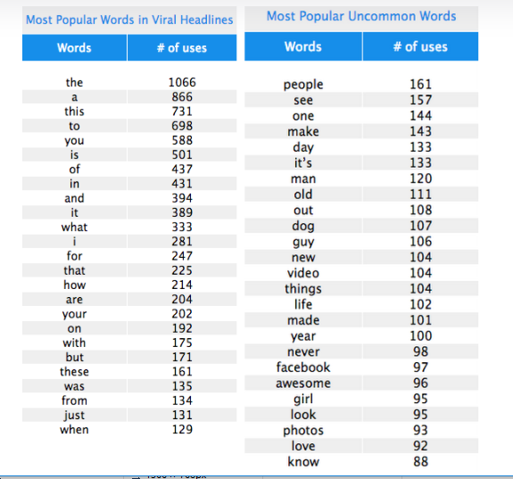
- Speak to your audience in a conversational tone
- You and Your get good results in headlines

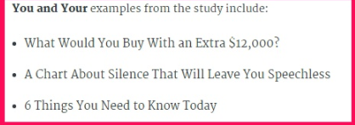

III. Utilize these when creating headlines
- Lists - 19% of viral headlines had a number. Lists and data backed headlines are heavily consumed. Ex. “10
- This - Draws specificity on the subject and creates an immediacy for the user to click on the article. Ex. “This is what you need to know about Facebook’s newsfeed changes”
- This is - the most popular 2-word phrase
- What, Which, When and Why – The reason for their effectiveness in a post title is possibly because they evoke our curiosity.
- Video - Specify in the headline that your audience doesn’t want to miss the video in your blog
- How to - Education and instruction - deliver value-added content

IV. Think social in the blog-creating process
- Focus on headlines - test various headlines and use different headlines for different social channels

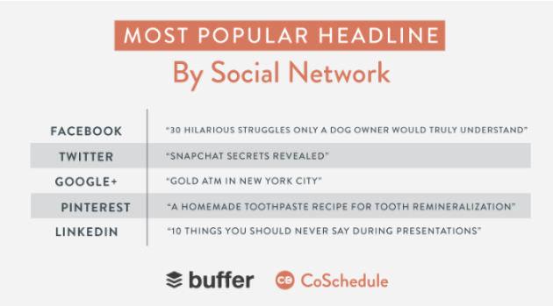
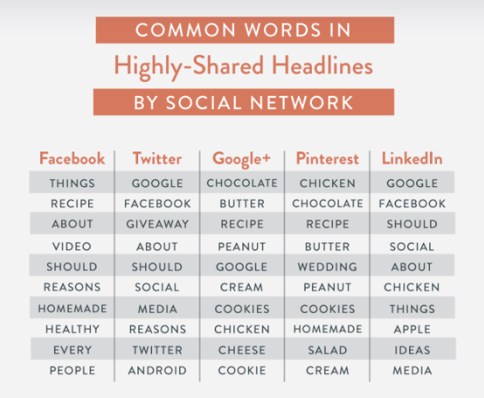

Create Content That Resonates with your Audience

- Videos
- Sort your blog content out of most traffic and create videos around those topics
- Look to your audience to find topics for videos - what do people want to know more about? What are they confused about? What are small businesses concerned about when it comes to digital marketing?
- Go outside your industry to your favorite brands
- Look at the videos your competitors are making
- Shorter videos are better - 60-90 seconds are ideal on both facebook and twitter

II. Get the most out of your content - think social in the blog-creating process
- create shareable content within your article - infographics, graphs
- Create a video to accompany the article

III. Mine trending topics for content
- Influencer Ann Handley utilized a trending pop culture topci (the crockpot) and related it to marketing



